L293D Motor Driver

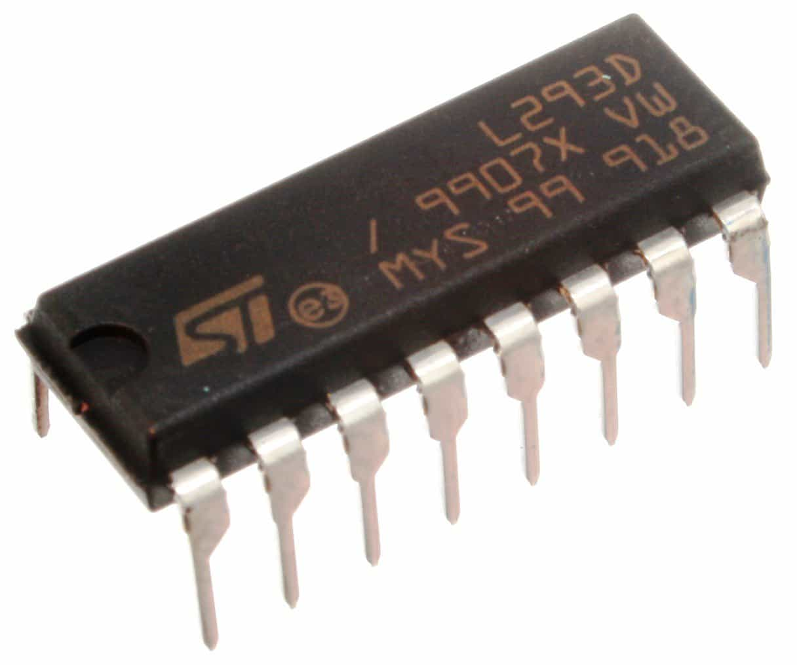

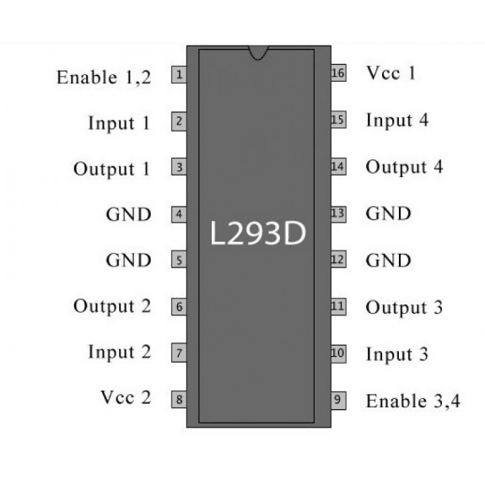

The L293D is a dual-channel H-Bridge motor driver capable of driving a pair of DC motors or one stepper motor.

That means it can individually drive up to two motors making it ideal for building two-wheel robot platforms.

Power Supply

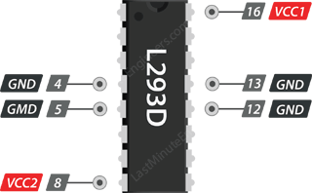

The L293D motor driver IC actually has two power input pins viz. ‘Vcc1’ and ‘Vcc2’.

Vcc1 is used for driving the internal logic circuitry which should be 5V.

From Vcc2 pin the H-Bridge gets its power for driving the motors which can be 4.5V to 36V. And they both sink to a common ground named GND

Output Terminals

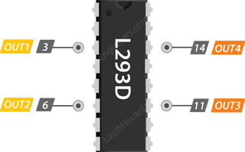

The L293D motor driver’s output channels for the motor A and B are brought out to pins OUT1,OUT2 and OUT3,OUT4 respectively.

You can connect two DC motors having voltages between 4.5 to 36V to these terminals.

Each channel on the IC can deliver up to 600mA to the DC motor. However, the amount of current supplied to the motor depends on system’s power supply.

## Control Pins

For each of the L293D’s channels, there are two types of control pins which allow us to control speed and spinning direction of the DC motors at the same time viz. Direction control pins & Speed control pins.

### **Direction Control Pins**

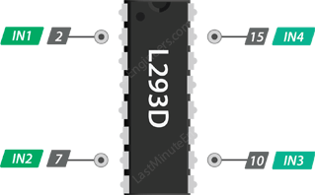

Using the direction control pins, we can control whether the motor spins forward or backward. These pins actually control the switches of the H-Bridge circuit inside L293D IC.

The IC has two direction control pins for each channel. The IN1,IN2 pins control the spinning direction of the motor A while IN3,IN4 control motor B.

The spinning direction of a motor can be controlled by applying either a logic HIGH(5 Volts) or logic LOW(Ground) to these pins. The below chart illustrates how this is done.

|  |  |  |
| --- | --- | --- |
| IN1 | IN2 | Spinning Direction |
| Low(0) | Low(0) | Motor OFF |
| High(1) | Low(0) | Forward |
| Low(0) | High(1) | Backward |
| High(1) | High(1) | Motor OFF |

### **Speed Control Pins**

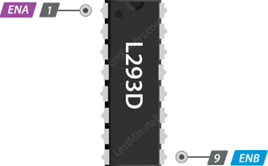

The speed control pins viz. ENA and ENB are used to turn ON, OFF and control speed of motor A and motor B respectively.

Pulling these pins HIGH will make the motors spin, pulling it LOW will make them stop. But, with Pulse Width Modulation (PWM), we can actually control the speed of the motors.